Name, Surname (Times New Roman, 14pt, bold, Right)
E-mail
Scientific degree
Name of University or Institution
City, Country
If there are co-authors, every author should be on a new row with the same formatting.

TITLE OF THE MANUSCRIPT (Times New Roman, 16pt, bold, center)

Abstract: (Times New Roman, Bold 12 pt, Justify, 250 – 300 words)
Keywords: (Times New Roman, Bold 12 pt, min 4, max 7)
JEL classification: (Times New Roman, Bold 12 pt)

Introduction and review of literature
Introduce the research topic, main objectives, scope, existing hypotheses and other key issues. A review and understanding of relevant literature should also be presented in this section. (Times New Roman,12 pt, Justify).

Methodology
The research methodology should be described in detail in this section. A description of the research, intellectual work performed should be presented. (Times New Roman,12 pt, Justify).

Title of the first paragraph (if applicable)
(Times New Roman,12 pt, Justify).
Figure 1. Title of the figure (Times New Roman, 12 pt, center)
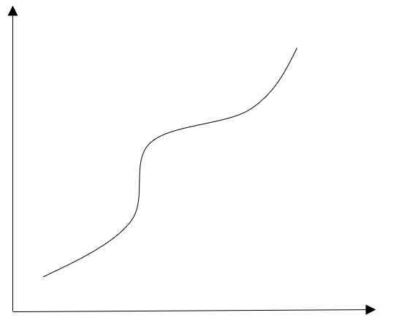
Source: Source of the figure (Times New Roman, 12 pt, center)
A figure should be centered. Data in the figure should be formatted with Times New Roman font, 12 pt.

Title of the second paragraph (if applicable)
(Times New Roman,12 pt, Justify).
Table 1. Title of the Table (Times New Roman, 12 pt, center)
Name | Year | Quantity
This is an example | This is an example | This is an example

Source: Source of the Table (Times New Roman, 12 pt, center)
A table should be centered. Data in the table should be formatted with Times New Roman font, 12 pt.
bulleted/numbered lists:
- A
- B
- C
- D

Title of the third paragraph (if applicable)
(Times New Roman,12 pt, Justify).
Use the Equation command to write formulas (insert > equation)

Results
In this section, present the main results of the research (Times New Roman,12 pt, Justify)

Conclusions
Discuss the importance of the work, present the possibilities of its practical and theoretical application. (Times New Roman,12 pt, Justify)

References
References are formatted according to the international bibliographical standard, APA-style. Follow the author's guidelines when preparing the reference (Times New Roman,12 pt, Justify)

